截图：

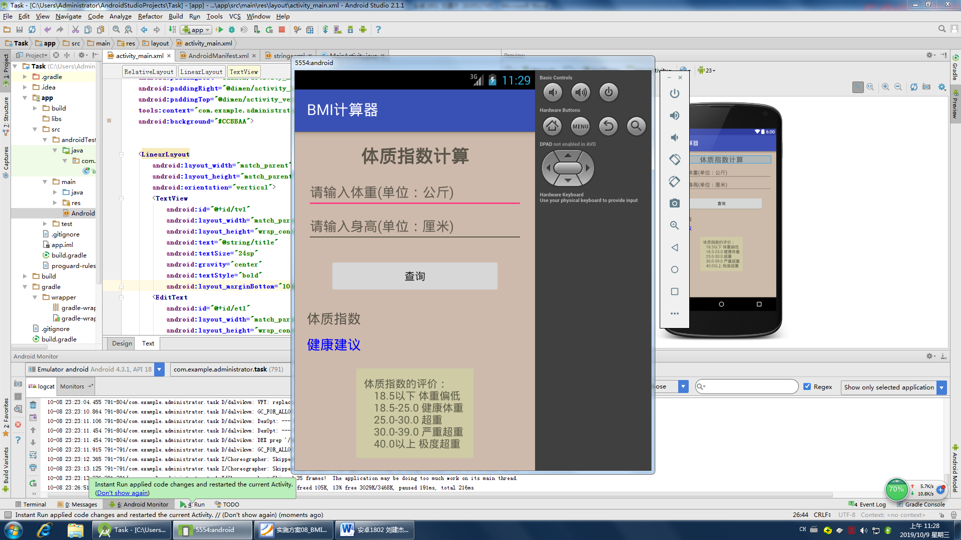

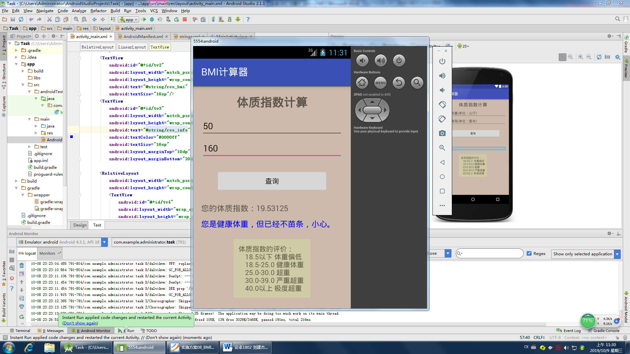

代码：

**import** android.support.v7.app.AppCompatActivity;  
**import** android.os.Bundle;  
**import** android.view.View;  
**import** android.widget.Button;  
**import** android.widget.EditText;  
**import** android.widget.TextView;  
  
**public class** MainActivity **extends** AppCompatActivity {  
 **private** EditText **et1**,**et2**;  
 **private** Button **bt1**;  
 **private** TextView **tv2**,**tv3**;  
 @Override  
 **protected void** onCreate(Bundle savedInstanceState) {  
 **super**.onCreate(savedInstanceState);  
 setContentView(R.layout.***activity_main***);  
 findView();  
 setListen();  
 }  
  
 **public void** findView(){  
 **et1** = (EditText)findViewById(R.id.***et1***);  
 **et2** = (EditText)findViewById(R.id.***et2***);  
 **bt1** = (Button)findViewById(R.id.***bt1***);  
 **tv2** = (TextView)findViewById(R.id.***tv2***);  
 **tv3** = (TextView)findViewById(R.id.***tv3***);  
 }  
 **public void** setListen(){  
 **bt1**.setOnClickListener(**new** OnclickClass());  
 }  
  
 **class** OnclickClass **implements** View.OnClickListener{  
 **double d1**,**d2**,**d3**;  
 String **info**;  
 @Override  
 **public void** onClick(View v) {  
 **if**(v == **bt1**){  
 **d1** = Double.*valueOf*(**et1**.getText().toString());  
 **d2** = Double.*valueOf*(**et2**.getText().toString());  
 **d3** = **d1** / (**d2** * **d2**) * 10000;  
 **tv2**.setText(**"您的体质指数："**+**d3**);  
 **if**(**d3** <= 18.5){  
 **info** = **"您太瘦，应做个体检，增加营养"**;  
 }**else if**(**d3** <= 25){  
 **if**(**d3** > 20 && **d3** <= 22){  
 **info** = **"恭喜！！您是标准身材，注意保持"**;  
 }**else**{  
 **info** = **"您是健康体重，但已经不苗条，小心。"**;  
 }  
 }**else if**(**d3** <= 30){  
 **info** = **"您超重了，应该立即减肥！"**;  
 }**else if**(**d3** <= 39){  
 **info** = **"您很胖，减肥已经是头等大事"**;  
 }**else**{  
 **info** = **"您非常胖，肥胖将危机您的健康！"**;  
 }  
 **tv3**.setText(**info**);  
 }  
 }  
 }  
}

*<?***xml version="1.0" encoding="utf-8"***?>*<**RelativeLayout xmlns:android="http://schemas.android.com/apk/res/android"  
 xmlns:tools="http://schemas.android.com/tools"  
 android:layout_width="match_parent"  
 android:layout_height="match_parent"  
 android:paddingBottom="@dimen/activity_vertical_margin"  
 android:paddingLeft="@dimen/activity_horizontal_margin"  
 android:paddingRight="@dimen/activity_horizontal_margin"  
 android:paddingTop="@dimen/activity_vertical_margin"  
 tools:context="com.example.administrator.task.MainActivity"  
 android:background="#CCBBAA"**>  
  
  
 <**LinearLayout  
 android:layout_width="match_parent"  
 android:layout_height="match_parent"  
 android:orientation="vertical"**>  
 <**TextView  
 android:id="@+id/tv1"  
 android:layout_width="match_parent"  
 android:layout_height="wrap_content"  
 android:text="@string/title"  
 android:textSize="24sp"  
 android:gravity="center"  
 android:textStyle="bold"  
 android:layout_marginBottom="10dp"**/>  
 <**EditText  
 android:id="@+id/et1"  
 android:layout_width="match_parent"  
 android:layout_height="wrap_content"  
 android:hint="@string/weight"**/>  
 <**EditText  
 android:id="@+id/et2"  
 android:layout_width="match_parent"  
 android:layout_height="wrap_content"  
 android:hint="@string/height"** />  
 <**Button  
 android:id="@+id/bt1"  
 android:layout_marginLeft="30dp"  
 android:layout_marginRight="30dp"  
 android:layout_width="match_parent"  
 android:layout_height="wrap_content"  
 android:text="@string/query"  
 android:layout_marginTop="20dp"  
 android:layout_marginBottom="20dp"** />  
 <**TextView  
 android:id="@+id/tv2"  
 android:layout_width="match_parent"  
 android:layout_height="wrap_content"  
 android:text="@string/res_bmi"  
 android:textSize="16sp"**/>  
 <**TextView  
 android:id="@+id/tv3"  
 android:layout_width="match_parent"  
 android:layout_height="wrap_content"  
 android:text="@string/res_info"  
 android:textColor="#0000ff"  
 android:textSize="16sp"  
 android:layout_marginTop="10dp"  
 android:layout_marginBottom="20dp"**/>  
  
 <**RelativeLayout  
 android:layout_width="match_parent"  
 android:layout_height="wrap_content"**>  
 <**TextView  
 android:id="@+id/tv4"  
 android:layout_width="wrap_content"  
 android:layout_height="wrap_content"  
 android:text="@string/all_info"  
 android:padding="10dp"  
 android:background="#CFCAA5"  
 android:layout_centerInParent="true"**/>  
  
 </**RelativeLayout**>  
 </**LinearLayout**>  
  
</**RelativeLayout**>